HEXAWARE - ASSIGNMENT 4

COURIER MANAGEMENT SYSTEM

NAME : SRINATH N S S

TASK 1 : Database Design

Design a SQL schema for a Courier Management System with tables for Customers, Couriers, Orders and Parcels. Define the relationships between these tables using appropriate foreign keys.

SQL QUERY FOR CREATING TABLES :

CREATE TABLE Users(

UserID INT PRIMARY KEY,

Name VARCHAR(255),

Email VARCHAR(255) UNIQUE,

Password VARCHAR(255),

ContactNumber VARCHAR(20),

Address TEXT

);

CREATE TABLE Courier (

CourierID INT PRIMARY KEY,

SenderName VARCHAR(255),

SenderAddress TEXT,

ReceiverName VARCHAR(255),

ReceiverAddress TEXT,

Weight DECIMAL(5, 2),

Status VARCHAR(50),

TrackingNumber VARCHAR(20) UNIQUE,

DeliveryDate DATE

);

CREATE TABLE CourierServices (

ServiceID INT PRIMARY KEY,

ServiceName VARCHAR(100),

Cost DECIMAL(8, 2)

);  
CREATE TABLE Employee (

EmployeeID INT PRIMARY KEY,

Name VARCHAR(255),

Email VARCHAR(255) UNIQUE,

ContactNumber VARCHAR(20),

Role VARCHAR(50),

Salary DECIMAL(10, 2)

);

CREATE TABLE Location (

LocationID INT PRIMARY KEY,

LocationName VARCHAR(100),

Address TEXT

);

CREATE TABLE Payment (

PaymentID INT PRIMARY KEY,

CourierID INT,

LocationID INT,

Amount DECIMAL(10, 2),

PaymentDate DATE,

FOREIGN KEY (CourierID) REFERENCES Courier(CourierID),

FOREIGN KEY (LocationID) REFERENCES Location(LocationID)

);

FOR INSERTING DATA INTO TABLES :

USE ASSIGNMENT

INSERT INTO Users (UserID, Name, Email, Password, ContactNumber, Address) VALUES

(1, 'RajKumar', 'raj@gmail.com', 'dsadsaddsdsd', '9876543210', 'Gandhipuram,Coimabtore'),

(2, 'RamKumar', 'rame@gmail.com', 'dasdasdasds', '9976332151', 'Anna Nagar , Theni');

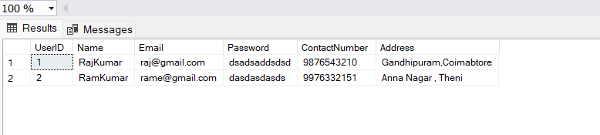

INSERT INTO Courier (CourierID, SenderName, SenderAddress, ReceiverName, ReceiverAddress, Weight, Status, TrackingNumber, DeliveryDate) VALUES

(1, 'Srinath', 'Church Street,Pollachi', 'Sujeeth', 'Layton Hall,Karur', 5.0, 'In transit', 'T1', '2024-08-12'),

(2, 'Aswath', 'Lilly Avenue ,Thennam', 'Sudarsan', 'JM Street,Kochi', 2.0, 'Delivered', 'T2', '2024-01-19');

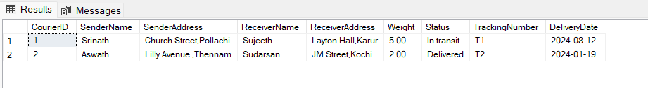

INSERT INTO CourierServices (ServiceID, ServiceName, Cost) VALUES

(1, 'Normal', 10),

(2, 'SuperFast', 20);

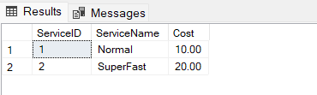

INSERT INTO Employee (EmployeeID, Name, Email, ContactNumber, Role, Salary) VALUES

(1, 'Sanjeev', 'sanjeev@gmail.com', '7826514568', 'Manager', 35000),

(2, 'Vikram', 'vikram@gmail.com', '9871248965', 'Delivery Agent', 15000);

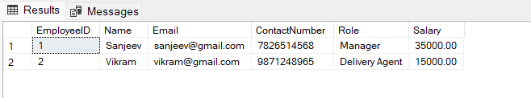

INSERT INTO Location (LocationID, LocationName, Address) VALUES

(1, 'StoreHouse', 'Chennai'),

(2, 'CustomerCare', 'Bangalore');

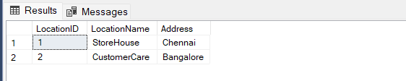

INSERT INTO Payment (PaymentID, CourierID, LocationID, Amount, PaymentDate) VALUES

(1, 1, 2, 10.00, '2024-04-08'),

(2, 2, 2, 20.00, '2024-04-09');

